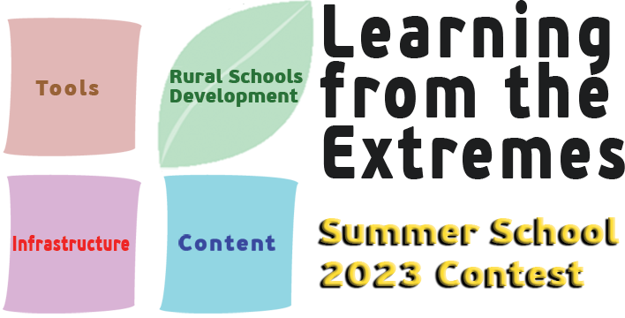

The purpose of the contest is to highlight and reward at european level the efforts of teachers from the LfE schools by supporting their participation in the Learning from the Extremes Summer School 2023 in order to present their school development projects and related activities.

The contest is aimed at teachers from the Learning from the Extremes schools. Each LfE school must upload a project on the LfE community portal. The description of the LfE School Project is freely formulated by the teacher, based on the available template. The description should address the following:
- How did you implement your project with the support of the technological solutions acquired for your school through the LfE funding?
- How is this project addressing the innovation plan of your school that you described in your original application?
- How does your project is referring to one of the three Rural Schools Innovation Strategies :
- Strengthened organization and support for rural schools
- Supporting equity and excellence in rural schools
- Supporting rural schools as community and educational spaces
- What is the impact of your project on students until now? How are they using the equipment and services that were purchased by the LfE funding?

The LfE School Project template includes 4 steps:
- Feel: Students identify problems in their local communities. They can also select topics related to global challenges. Students observe problems and try to engage with those who are affected, discuss their thoughts in groups, and make a plan of action, based on scientific evidences.
- Imagine: Students envision and develop creative solutions that can be replicated easily, reach the maximum number of people, generate long-lasting change, and make a quick impact. They are coming in contact with external actors, they are looking for data to support their ideas and they are proposing a series of solutions.
- Create: Students are implementing the project and they are interacting with external stakeholders to communicate their findings.
- Share: Students share their stories with other schools in the community and local media.
Each project must submitted on the LfE community portal and the link must also be shared via email to info@learningfromtheextremes.eu. In case of any technical problem, interested parties can contact the competition organizers by mail to info@learningfromtheextremes.eu.

Each eligible entry will be assessed against the following criteria:
- Quality of the description of the implemention of the project with the support of the technological solutions acquired through the LfE funding (30%)
- Quality of the description of how the project is addressing the innovation plan that was described in the original application? (25%)
- Quality of the description of how the project is referring to one of the three Rural Schools Innovation Strategies (20%)
- Quality of the description of the impact of the project on students and the ways they are using the equipment and services that were purchased by the LfE funding (25%)

Eligible entries will be clustered on national level and assessed against the same criteria by the national coordinators. Each national coordinator will be responsible for this evaluation and selection phase which will result in the selection of 10 entries. National coordinators are requested to propose an entry in the common reserve list for the remaining 4 entries to be selected. Each national coordinator has to put a score to each entry except of the one that was submitted in their country. The final selection will be made by the Learning from the Extremes Selection Panel (includes the Project Coordinator and the representatives of the National Coordinators and the organiser of the Learning from the Extremes Summer School) based on the decisions and scores of the National Coordinators.

The teachers of the 14 selected entries will be awarded with the right to participate free of charge in the Learning from the Extremes Summer School 2023 which will take place on July 2-7, 2023 in Marathon Attica.
The prize covers the costs of participating in the training program and the related activities, accommodation and food at the hotel that will host the event, as well as travel to and from the venue before the start and after the end of the training.

Contest closes: 31 May 2023

Announcement of results: 5 June 2023

